
REPUBLIC OF CAMEROON
PEACE-WORK-FATHERLAND
UNIVERSITY OF BUEA
FACULTY OF ENGINEERING AND TECHNOLOGY

DEPARTMENT OF COMPUTER ENGINEERING

CEF 440: INTERNET PROGRAMMING AND MOBILE PROGRAMMING

TASK 6: DATABASE DESIGN AND IMPLEMENTATION

COURSE INSTRUCTOR: Dr Nkemeni Valery

PRESENTED BY GROUP 8:

SALLE YIMNAI BRYAN NZUME ETUGE: FE23A140
MANIKEU TINKEU MARIE ANGE PRINCESSE: FE23A086
FONGANG FAITH ACHO: FE23A059
ANDIGEMA JOYCE ANI: FE23A012
NDIP SAMUEL AGBOR OJONG: FE23A101

Table of Contents
1. Introduction 1
1.1 Task Objectives 1
1.2 Architectural Context and Design Inputs 1
1.3 Tools and Technologies 2
2. Data Elements 2
2.1 Entities Overview 2
2.2 Data Dictionary (principal entities) 3
2.2.1 warning_light 3
2.2.2 engine_sound 3
2.2.3 repair_suggestion and video_link 3
2.2.4 diagnosis_history (user data, device-only) 4
3. Conceptual Design 4
3.1 The Conceptual Model 4
3.2 Key Design Decisions 5
3.3 Relationships and Cardinalities 5
4. ER Diagram 5
5. Database Implementation 6
5.1 On-Device Database (Room / SQLite) 6
5.2 Server Database (node:sqlite) 7
5.3 Online Database (Google Cloud Firestore) 7
6. Backend Implementation 8
6.1 Managed Backend — Firebase (Cloud Firestore) 8
6.2 Self-hosted Backend — Node.js + Express 8
7. Connecting the Database to the Backend 9
8. Connecting the Mobile App to the Backend and Database 9
8.1 The Repository Seam 10
8.2 The Retrofit Sync Client 10
8.3 The Firestore Connection (production path) 11
9. Testing and Verification 11
9.1 Backend and Sync Verification 11
9.2 Firebase Verification 12
9.3 Screenshots of the Running System 12
10. Requirements Traceability 16
11. Challenges and Design Decisions 17
11.1 Keeping two databases in step 17
11.2 Modelling content that belongs to either a light or a sound 17
11.3 Honouring privacy at the schema level 17
11.4 A synchronous interface over an asynchronous store 17
12. Conclusion 17

1. Introduction

1.1 Task Objectives
This report documents Task 6 of the CarDiag project — the design and implementation of the application's database and backend. As set out in the course outline, Task 6 covers six deliverables:
- Data elements — identifying the data the system must store.
- Conceptual design — the entities, attributes and relationships that organise that data.
- ER diagram — a visual entity-relationship model of the schema.
- Database implementation — the physical databases (on-device SQLite via Room, and the server's SQLite store).
- Backend implementation — the REST service that exposes the master knowledge base.
- Connecting the database to the backend — and connecting the mobile app to that backend.
Each deliverable builds on the system models from Task 4 (the class diagram, the Level-0 data-flow diagram and the deployment diagram) and on the frontend delivered in Task 5, which was deliberately written against repository and service interfaces so that this database and backend could be attached without changing any screen.

1.2 Architectural Context and Design Inputs
CarDiag is an offline-first diagnostic assistant. The baselined requirements fix several database-relevant decisions that this task implements directly:
- Storage technology. The SRS and Task 4 specify a bundled SQLite knowledge base on the device and a REST API over HTTPS for an online sync server, with delta updates (the deployment diagram names GET /db-version and GET /delta). This task uses SQLite on both ends and Room as the on-device persistence library.
- Offline-first (FR11, NFR02). All core features must work from first launch with no network; therefore the device carries a complete copy of the knowledge base, seeded on first run, and the server is only an optional source of updates.
- Privacy (NFR05). Raw images/audio and the user's private data must never be transmitted. Consequently the server database stores only the knowledge base; the user's diagnosis history, vehicles and saved mechanics live exclusively on the device.
- Extensibility (NFR09). The schema must support delta updates and future growth (more symbols, an engine-generation field). Revision columns and a metadata table provide this.
- Managed online store. The shared catalogue and knowledge base are hosted in Google Cloud Firestore (the free Spark plan); the device pulls updates by catalogue version. Per NFR05, private user data is never placed in the cloud — only on the device.
Because Task 5 routed all data access through the CarDiagRepository interface, Task 6 is purely additive: a new RoomCarDiagRepository implementation now backs the same interface, and the device connects to the online store — Google Cloud Firestore — through a guarded FirebaseService. A self-hosted Node.js + SQLite REST server (reached via Retrofit) is also provided as an alternative backend. No UI or ViewModel code changed.

1.3 Tools and Technologies
Concern | Technology | Role
On-device database | SQLite via Jetpack Room 2.6.1 (+ KSP) | Bundled knowledge base + private user data on the phone.
Online store (primary) | Google Cloud Firestore (Firebase BOM 33.7) | Shared catalogue + knowledge base in the cloud; delta-synced to the device.
App–cloud transport | Firebase Firestore SDK + Kotlin coroutines | Reads the cloud store; offline-cached; private data excluded.
Backend (alternative) | Node.js + Express 4 + node:sqlite | Self-hosted read-only REST API with delta sync.
App–server transport | Retrofit 2.11 + Gson + coroutines | Typed HTTP/JSON client for the self-hosted option.
Modelling | Draw-style ER & data-flow diagrams | Conceptual and physical design artefacts.

2. Data Elements
The data elements were derived from the Task 4 class diagram and the curated catalogue used by the prototype. They fall into three groups: the knowledge base (the diagnostic content, data store DS1), the user data (private, device-only, DS2), and small lookup/metadata tables.

2.1 Entities Overview
Entity | Group | Purpose
warning_light | Knowledge base | A dashboard warning-light symbol and its explanation.
light_cause | Knowledge base | Possible causes of a warning light (ordered).
engine_sound | Knowledge base | An engine-sound fault category (audio pathway).
sound_cause | Knowledge base | Possible causes of an engine sound (ordered).
followup_question | Knowledge base | Guided follow-up questions for a sound (FR07).
repair_suggestion | Knowledge base | Tiered repair guidance for a light or a sound (WK-06).
video_link | Knowledge base | Curated expert video reference for a light or sound (FR10).
urgency | Lookup | The four-level urgency scale (FR08).
repair_tier | Lookup | The three repair tiers (no tools / basic / workshop).
vehicle | User data | A saved vehicle in the garage (FR15).
diagnosis_history | User data | A saved diagnosis session (FR16).
emergency_contact | User data | A saved mechanic to call on critical results (FR14a).
db_meta | Metadata | Catalogue version, onboarding flag, active vehicle.

2.2 Data Dictionary (principal entities)
The attribute-level data dictionary for the central entities follows. PK marks a primary key and FK a foreign key.

2.2.1 warning_light
Attribute | Type | Key | Description
symbol_id | TEXT | PK | Stable identifier (e.g. 'oil', 'check').
name | TEXT |  | Display name, e.g. 'Oil Pressure'.
icon | TEXT |  | Key into the app icon set.
category | TEXT |  | Engine / Brakes / Electrical / Tyres / Safety.
urgency | TEXT | FK | References urgency(level).
base_confidence | REAL |  | Default classifier confidence (0–1).
description | TEXT |  | Plain-language explanation.
first_action | TEXT |  | The single recommended first action.
engine_generation | TEXT |  | Optional engine tag (GAP-08).
rev | INTEGER |  | Revision for delta sync.

2.2.2 engine_sound
Attribute | Type | Key | Description
sound_id | TEXT | PK | Stable identifier (e.g. 'knocking').
name | TEXT |  | Display name.
urgency | TEXT | FK | References urgency(level).
base_confidence | REAL |  | Default classifier confidence.
description | TEXT |  | Plain-language explanation.
first_action | TEXT |  | Recommended first action.
rev | INTEGER |  | Revision for delta sync.

2.2.3 repair_suggestion and video_link
Attribute | Type | Key | Description
id | INTEGER | PK | Auto-increment surrogate key.
symbol_id | TEXT | FK | Owner light (nullable).
sound_id | TEXT | FK | Owner sound (nullable).
tier | TEXT | FK | repair_suggestion only → repair_tier(tier).
text / title | TEXT |  | Repair instruction / video title.
channel, duration_seconds, youtube_url | TEXT/INT |  | video_link only — source metadata.
ord | INTEGER |  | Display order.
A CHECK constraint enforces that exactly one owner is set on each repair_suggestion / video_link row (a row belongs to a light XOR a sound).

2.2.4 diagnosis_history (user data, device-only)
Attribute | Type | Key | Description
id | TEXT | PK | Session identifier.
type | TEXT |  | camera / audio / manual.
name | TEXT |  | Fault name shown to the user.
symbol_id | TEXT | FK | Light, if any (nullable).
sound_id | TEXT | FK | Sound, if any (nullable).
urgency | TEXT | FK | Urgency snapshot → urgency(level).
confidence | REAL |  | Result confidence.
created_at | INTEGER |  | Unix-millis timestamp.
note | TEXT |  | Optional user note (FR16).
The remaining tables are compact: vehicle(id PK, make, model, year, fuel, engine, is_active); emergency_contact(id PK, name, phone, priority); light_cause / sound_cause(id PK, owner FK, cause, ord); followup_question(id PK, sound_id FK, question, ord); urgency(level PK, rank, label, action, short, color); repair_tier(tier PK, label, sub, ord); db_meta(key PK, value).

3. Conceptual Design

3.1 The Conceptual Model
Two entities form the core of the model because they represent the two automated diagnostic pathways: a warning_light (camera / manual pathway) and an engine_sound (audio pathway). Each is the parent of several dependent entities — its possible causes, its tiered repair suggestions, and its curated expert videos; an engine_sound additionally owns a set of follow-up questions. Two small lookup entities, urgency and repair_tier, provide the controlled vocabularies that the content references, guaranteeing that every result carries a valid urgency level and that every repair is tagged with a valid tier.
The user-owned entities — vehicle, diagnosis_history and emergency_contact — are deliberately kept in a separate logical group. A diagnosis_history row may reference the light or sound it came from and always records an urgency, but it is created and stored entirely on the device and is never written to the server. This separation is the database-level expression of the privacy requirement (NFR05).

3.2 Key Design Decisions
- Normalisation. The schema is normalised to third normal form: repeating groups (causes, repairs, videos, follow-ups) are moved into child tables keyed by the parent, rather than stored as delimited strings, which keeps them queryable and individually updatable.
- Polymorphic ownership. repair_suggestion and video_link can belong to either a light or a sound. This is modelled with two nullable foreign keys plus a CHECK constraint that exactly one is set — a simple, referentially-sound alternative to a generic supertype table.
- Lookups over enumerations. Urgency and tier are stored as short text codes that reference lookup tables, so their labels, colours and ordering live in data, not in code, and can be updated by a future sync.
- Revision + metadata for sync. Each synced record carries a rev column and the database keeps a version in db_meta, which together drive an efficient delta feed (only records newer than the client's version are sent).
- Two stores, one schema. The device (Room) and the server (node:sqlite) share the same knowledge-base schema, so synchronisation is a direct row-for-row upsert; the device schema simply adds the private user tables.

3.3 Relationships and Cardinalities
Relationship | Cardinality
urgency — warning_light | 1 to many
urgency — engine_sound | 1 to many
urgency — diagnosis_history | 1 to many
warning_light — light_cause | 1 to many
warning_light — repair_suggestion | 1 to many
warning_light — video_link | 1 to many
engine_sound — sound_cause | 1 to many
engine_sound — followup_question | 1 to many
engine_sound — repair_suggestion | 1 to many
engine_sound — video_link | 1 to many
repair_tier — repair_suggestion | 1 to many
warning_light / engine_sound — diagnosis_history | 0..1 to many

4. ER Diagram
Figure 1 presents the complete entity-relationship model. The dashed groupings make the privacy boundary explicit: the knowledge base (left and centre) is bundled on the device and synchronised from the server, while the user data (right) is device-only and never transmitted. Primary keys are underlined and foreign keys are marked (FK); a line reads one (the solid dot) to many (the open ring).
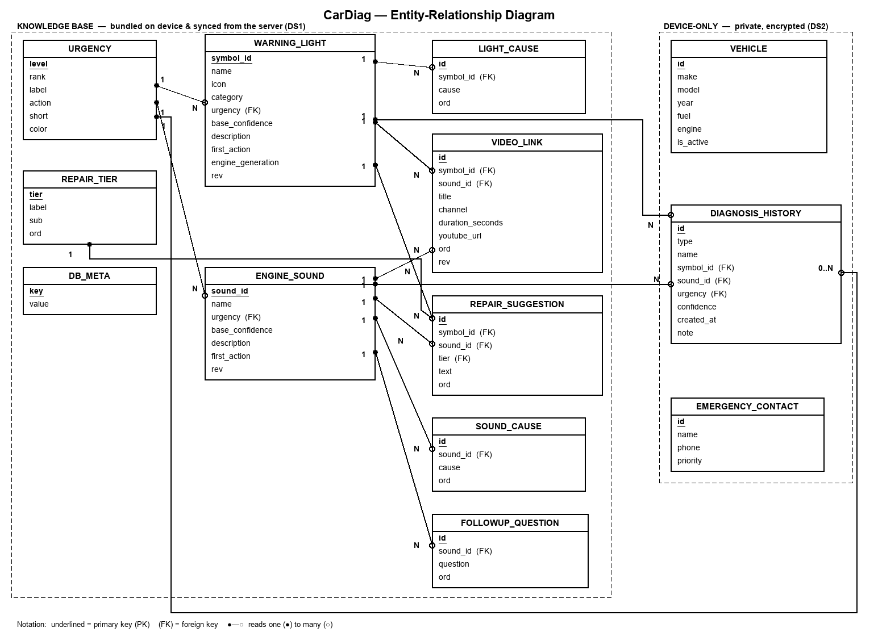
Figure 1: CarDiag entity-relationship diagram (knowledge base vs. device-only user data).

5. Database Implementation
Two physical databases were implemented from the model above, both using SQLite.

5.1 On-Device Database (Room / SQLite)
On the phone, the schema is implemented with Jetpack Room. Each table is a Room @Entity, accessed through a single @Dao, and assembled by a CarDiagDatabase. The database is created and seeded from the bundled catalogue on first launch, so every core feature works offline immediately (FR11). The entity below is representative:
@Entity(tableName = "warning_light")
data class WarningLightEntity(
@PrimaryKey val symbolId: String,
val name: String, val iconId: String, val category: String,
val urgency: String, // Urgency.id (FK -> urgency)
val baseConfidence: Float,
val description: String, val firstAction: String,
val engineGeneration: String? = null,
val rev: Int = 1,
)
The DAO exposes ordered reads for assembling domain objects and conflict-replacing inserts used by both seeding and sync:
@Dao interface CarDiagDao {
@Query("SELECT * FROM warning_light ORDER BY symbolId")
fun lights(): List<WarningLightEntity>
@Query("SELECT COUNT(*) FROM warning_light") fun lightCount(): Int
@Insert(onConflict = OnConflictStrategy.REPLACE)
fun insertLights(rows: List<WarningLightEntity>)
// ... causes, repairs, videos, sounds, user tables, meta ...
}
RoomCarDiagRepository implements the Task 5 CarDiagRepository interface: on construction it seeds the knowledge base from the bundled KnowledgeBase if the tables are empty, then serves lights/sounds from SQLite and reads/writes the user's AppState (history, vehicles, contacts) through the same database. Persisting state is a small wholesale replace:
override fun saveState(state: AppState) {
dao.clearVehicles()
dao.insertVehicles(state.vehicles.map { it.toEntity(it.id == state.activeVehicleId) })
dao.clearHistory(); dao.insertHistory(state.history.map { it.toEntity() })
dao.clearContacts(); dao.insertContacts(state.contacts.mapIndexed { i, c -> c.toEntity(i) })
dao.putMeta(MetaEntity("onboarded", state.onboarded.toString()))
}
Encryption at rest (NFR08) is provided in production by opening the Room database through SQLCipher; the v1 build keeps a standard SQLite file and a 'Delete all my data' action in Settings clears the user tables.

5.2 Server Database (node:sqlite)
On the server the same knowledge-base schema is created from a single DDL script (server/src/schema.sql). The central definitions show the foreign keys and the exactly-one-owner constraint:
CREATE TABLE warning_light (
symbol_id TEXT PRIMARY KEY,
name TEXT, icon TEXT, category TEXT,
urgency TEXT NOT NULL REFERENCES urgency(level),
base_confidence REAL, description TEXT, first_action TEXT,
engine_generation TEXT, rev INTEGER NOT NULL DEFAULT 1);

CREATE TABLE repair_suggestion (
id INTEGER PRIMARY KEY AUTOINCREMENT,
symbol_id TEXT REFERENCES warning_light(symbol_id) ON DELETE CASCADE,
sound_id TEXT REFERENCES engine_sound(sound_id) ON DELETE CASCADE,
tier TEXT NOT NULL REFERENCES repair_tier(tier),
text TEXT NOT NULL, ord INTEGER NOT NULL,
CHECK ((symbol_id IS NULL) <> (sound_id IS NULL)));

The server is seeded on first run from the same curated catalogue the app bundles, so the two databases start identical. This guarantees that synchronisation only ever has to reconcile genuine content changes.

5.3 Online Database (Google Cloud Firestore)
The production online store is a Google Cloud Firestore database (named cardiag) on the free Spark plan. Firestore is a NoSQL document store, so the relational schema above is mapped to collections of documents: each parent record becomes one document, and its ordered children (causes, repairs, videos, follow-ups) are embedded as arrays inside that document — the same denormalised shape the result screen consumes, fetched in a single read. Only the shared knowledge base and catalogue live here; there are no user-data collections, so privacy (NFR05) is again enforced structurally.
Collection / document | Contents
warningLights/{symbolId} | name, icon, category, urgency, baseConfidence, description, firstAction, rev; arrays: causes, repairs, videos.
engineSounds/{soundId} | name, urgency, baseConfidence, description, firstAction, rev; arrays: causes, followups, repairs, videos.
vehicleCatalog/{id} | make, model, years, fuel, engine, bodyType, imageUrl — the searchable vehicle catalogue.
meta/catalogue | version — bumped when content changes, driving delta sync.
The database is populated once by a seeding script (server/seed-firestore.js) that reads the same curated catalogue and writes it through the Firestore REST API; the current database holds 24 warning lights, 5 engine sounds and 40 catalogue vehicles at version 2. Access is governed by security rules that allow the app to read the shared collections but deny all client writes (edits are done from the console / an admin tool):
match /databases/{database}/documents {
match /{collection}/{doc} {
allow read: if collection in
['vehicleCatalog','warningLights','engineSounds','videos','meta'];
allow write: if false; // shared data is read-only to the app
}
}

6. Backend Implementation
CarDiag uses a managed serverless backend (Firebase) in production, with a self-hosted Node.js service provided as a portable alternative. Both expose the same shared knowledge base read-only; editing the catalogue through an authenticated admin interface is future work (Task 4, Version 2).

6.1 Managed Backend — Firebase (Cloud Firestore)
Firebase provides the backend with no server to operate: Cloud Firestore stores the documents (Section 5.3), its security rules are the authorisation layer, and the client SDK fetches documents directly over HTTPS with transparent offline caching. The app reads the meta/catalogue version and, when it is newer than the local copy, pulls the warningLights and engineSounds collections and upserts them into the on-device Room database; the vehicle catalogue is read the same way. The seeding script doubles as the update tool. This is the path wired into the shipped app via FirebaseService (Section 8.3).

6.2 Self-hosted Backend — Node.js + Express
As a portable alternative, a small Node.js + Express service exposes the same master knowledge base read-only. It opens the SQLite database on start (creating and seeding it if absent) and serves the endpoints below.
Method & path | Purpose
GET /api/health | Liveness + current catalogue version.
GET /api/db-version | { version } — cheap probe before syncing.
GET /api/catalog | Full knowledge base (urgency, tiers, lights, sounds).
GET /api/delta?since=N | Records whose rev > N (delta sync).
GET /api/warning-lights[/:id] | Warning-light resource(s).
GET /api/engine-sounds[/:id] | Engine-sound resource(s).
GET /api/urgency | The four-level urgency lookup.
Each warning-light or engine-sound record is returned fully assembled — its causes, tiered repairs and videos nested — so the client receives exactly what a result screen needs in one call. The delta endpoint validates its query parameter and returns only changed rows:
app.get('/api/delta', (req, res) => {
const since = Number.parseInt(req.query.since, 10);
if (Number.isNaN(since) || since < 0)
return res.status(400).json({ error: 'since must be >= 0' });
res.json(db.delta(since)); // { version, since, lights, sounds }
});

7. Connecting the Database to the Backend
The backend talks to its SQLite database through Node's built-in node:sqlite driver — no ORM is required. The connection is opened once at start-up, foreign keys are enabled, the schema is applied, and the database is seeded if it has no version row:
const { DatabaseSync } = require('node:sqlite');
db = new DatabaseSync(DB_PATH);
db.exec('PRAGMA foreign_keys = ON;');
db.exec(fs.readFileSync(SCHEMA_PATH, 'utf8'));
if (!db.prepare("SELECT value FROM db_meta WHERE key='version'").get())
seed(db);
All reads and writes use prepared statements, and seeding runs inside a single transaction for atomicity. A record is assembled by querying the parent row and its ordered children, for example a warning light:
const l = db.prepare('SELECT * FROM warning_light WHERE symbol_id=?').get(id);
l.causes = db.prepare('SELECT cause FROM light_cause WHERE symbol_id=? ORDER BY ord')
.all(id).map(r => r.cause);
l.repairs = db.prepare('SELECT tier,text FROM repair_suggestion WHERE symbol_id=? ORDER BY ord').all(id);
l.videos = db.prepare('SELECT title,channel,duration_seconds AS dur FROM video_link WHERE symbol_id=? ORDER BY ord').all(id);

8. Connecting the Mobile App to the Backend and Database
Figure 2 traces the full path from the server database to the screen. Each hop is a small, replaceable component, and the whole right-hand side runs offline using the on-device database alone.
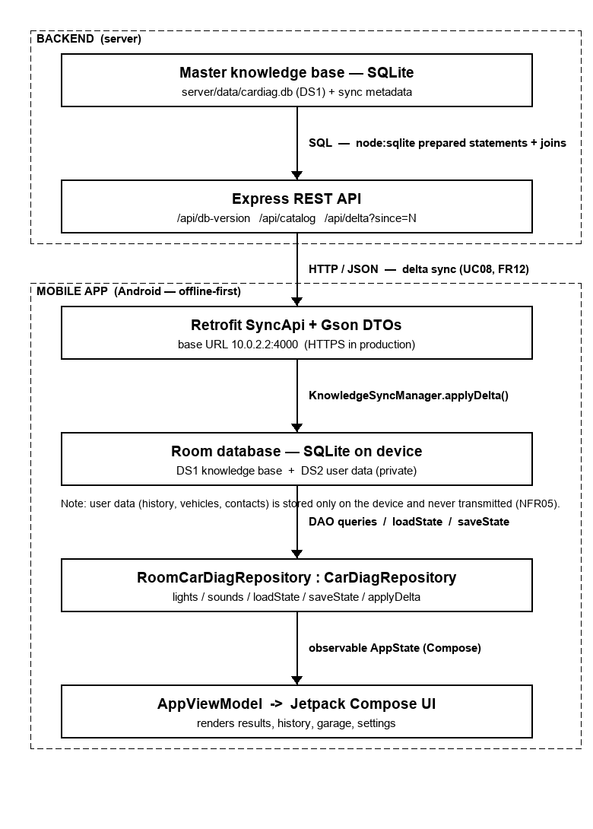
Figure 2: End-to-end data flow: server SQLite → REST → Retrofit → Room → repository → UI.

8.1 The Repository Seam
The app consumes data only through the CarDiagRepository interface defined in Task 5. Task 6 supplies a Room-backed implementation and selects it in one place — the application's composition root — so no screen or ViewModel changed:
class CarDiagApplication : Application() {
val repository: CarDiagRepository by lazy { RoomCarDiagRepository(this) }
val syncManager by lazy {
KnowledgeSyncManager(SyncApi.create(), repository as RoomCarDiagRepository) }
}

8.2 The Retrofit Sync Client
A Retrofit interface mirrors the server's REST contract, with Gson mapping the JSON onto Kotlin DTOs that are then converted to domain objects:
interface SyncApi {
@GET("api/db-version") suspend fun version(): VersionDto
@GET("api/delta") suspend fun delta(@Query("since") since: Int): DeltaDto
}
KnowledgeSyncManager performs the delta exchange off the main thread: it compares the local catalogue version with the server's, pulls only newer records, and upserts them into Room through RoomCarDiagRepository.applyDelta(). If the server is unreachable the call fails gracefully and the app continues on its local copy (FR11):
suspend fun sync() = withContext(Dispatchers.IO) { runCatching {
val local = repository.localVersion()
if (api.version().version <= local) return@runCatching Result(updated = false, local)
val d = api.delta(since = local)
repository.applyDelta(d.lights.map { it.toDomain() }, d.sounds.map { it.toDomain() }, d.version)
Result(updated = true, d.version, d.lights.size, d.sounds.size)
} }
The emulator reaches the local server at 10.0.2.2:4000; a cleartext exception is declared only for that development host, while all other traffic remains HTTPS-only (Constraint C09). Camera and microphone diagnosis continue to use the on-device classifier seam (DiagnosisService) and never call the network.

8.3 The Firestore Connection (production path)
In the shipped app the same repository seam is fed by Firestore. FirebaseService targets the named cardiag database, reads the shared collections and maps each document back to the domain model. Every call is guarded, so a missing configuration, an absent database or no connectivity simply yields empty results and the app continues on its bundled local data (FR11):
private val db get() = FirebaseFirestore.getInstance("cardiag")

suspend fun syncFromFirebase() {
if (!firebase.isAvailable) return
val remote = firebase.catalogueVersion() ?: return
if (remote <= repository.localVersion()) return // already current
repository.applyDelta(firebase.warningLights(),
firebase.engineSounds(), remote) // upsert into Room
}
The Add-vehicle search reads the vehicleCatalog collection the same way, falling back to the bundled catalogue when offline. Because both the Firestore and Retrofit paths drive the identical RoomCarDiagRepository.applyDelta(), the rest of the app is unaware of which backend supplied the update.

9. Testing and Verification

9.1 Backend and Sync Verification
The self-hosted backend was run locally and exercised over HTTP. The database seeded correctly and every endpoint returned the expected, fully-assembled data:
Request | Observed result
GET /api/health | { status: 'ok', version }
GET /api/catalog | 4 urgency levels, 3 tiers, 24 lights, 5 sounds
GET /api/warning-lights/oil | Oil Pressure — critical, 4 causes, 3 repairs, 2 videos
GET /api/engine-sounds/knocking | Knocking — high, 3 causes, 3 follow-up questions
GET /api/delta?since=0 | 24 lights + 5 sounds (full catalogue)
GET /api/delta?since=N | Only records changed since N (none newer ⇒ empty)
A representative assembled response (abridged) confirms the nested shape the client consumes:
GET /api/warning-lights/oil
{ "id":"oil", "name":"Oil Pressure", "urgency":"critical",
"confidence":0.94, "firstAction":"Pull over safely and switch off ...",
"causes":["Low engine oil level", "Failing oil pump", ...],
"repairs":[{"tier":"no_tools","text":"Stop the engine ..."}, ...],
"videos":[{"title":"Why the oil light means STOP","dur":184}, ...] }
On the device side, the Room schema, DAO, mappers, repository and sync clients are implemented against the existing interfaces and wired in the application's composition root, and the project's database/network dependencies (Room + KSP, Firebase Firestore, Retrofit + Gson, coroutines) are declared in the module build. The app is built and run from Android Studio against an emulator or device (API 26+); with a newer catalogue published, a delta pull updates the local copy, and with no network the app continues from its seeded on-device database.

9.2 Firebase Verification
The Firestore database was seeded and verified over the REST API. The cardiag database returned meta/catalogue version 2 with 24 warningLights, 5 engineSounds and 40 vehicleCatalog documents; the security rules allow the app to read these shared collections and deny client writes. On launch the app reads the catalogue version and (when newer) delta-syncs the knowledge base into Room, and the Add-vehicle search lists the cloud catalogue — while every core feature continues to work offline from the on-device database.

9.3 Screenshots of the Running System
The figures below show the implemented application and the seeded Firebase database.
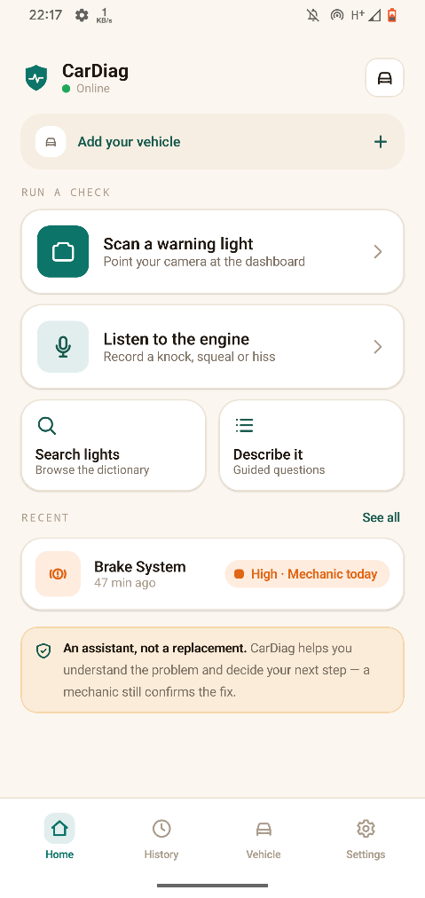  Figure 3: Home hub — three pathways, live online/offline indicator and the active vehicle. | 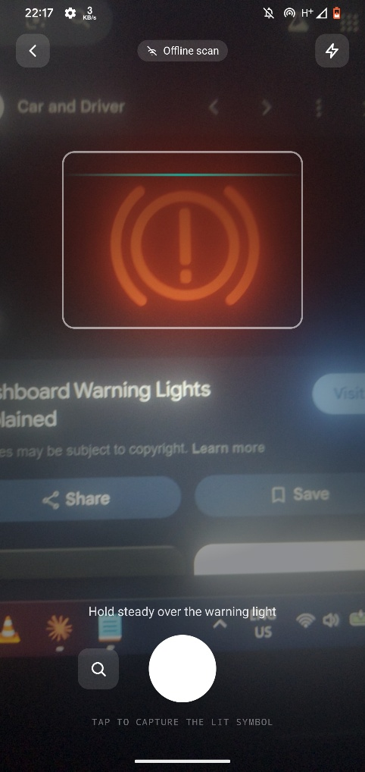  Figure 4: Camera scan — live preview with the alignment reticle.
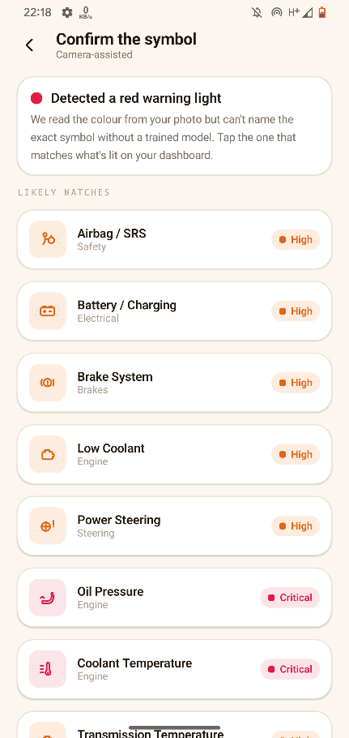  Figure 5: Colour triage — detected colour and candidate symbols to confirm. | 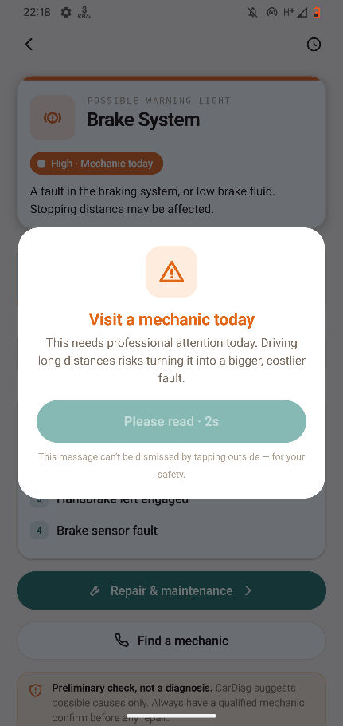  Figure 6: Result with the non-dismissible Critical safety prompt.
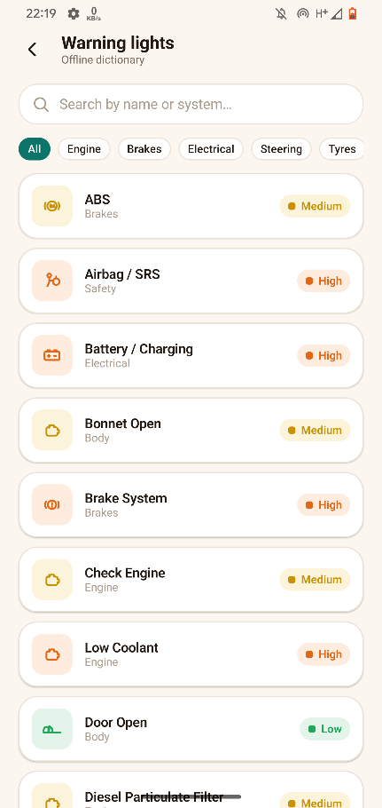  Figure 7: Manual search across the expanded (24-light) offline dictionary. | 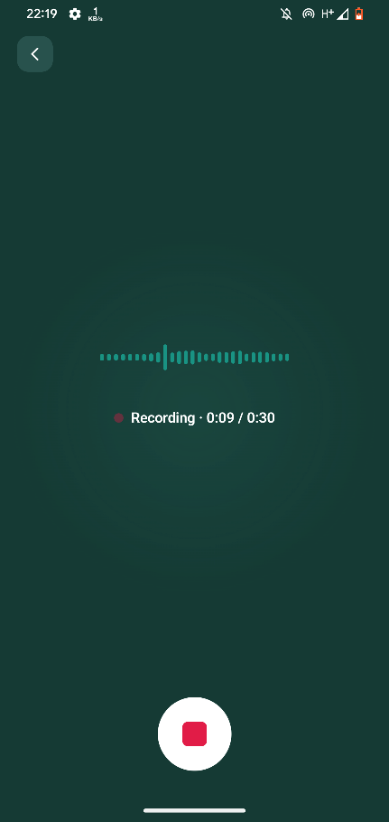  Figure 8: Engine-sound recording from the real microphone.
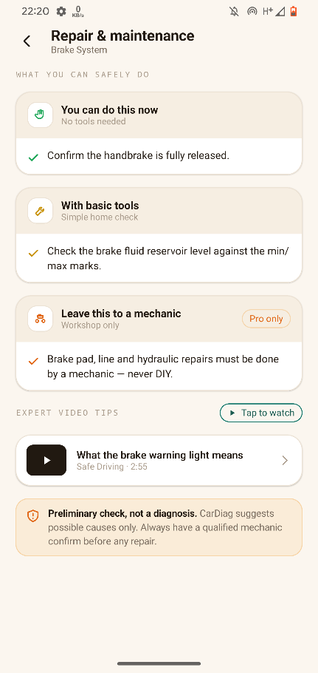  Figure 9: Repair tiers and an expert video (opens YouTube when online). | 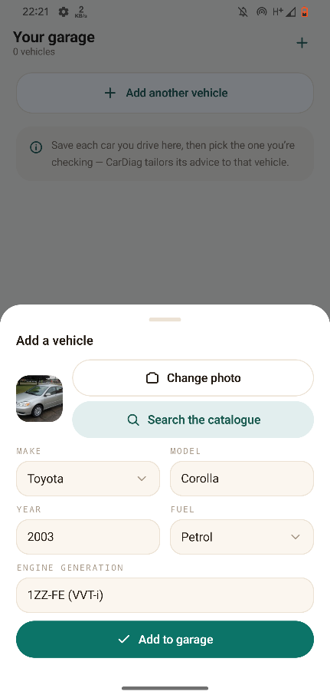  Figure 10: Add a vehicle — catalogue search and photo; the image replaces the icon.
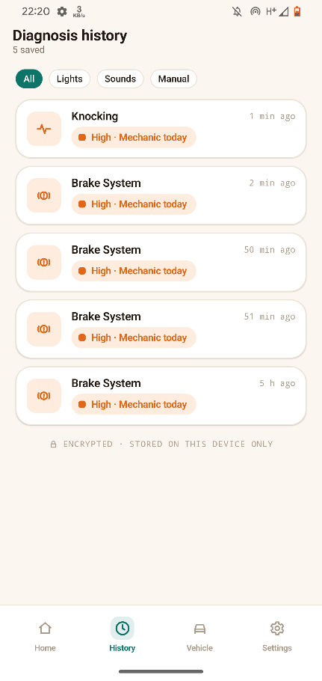  Figure 11: Diagnosis history, stored on-device. | 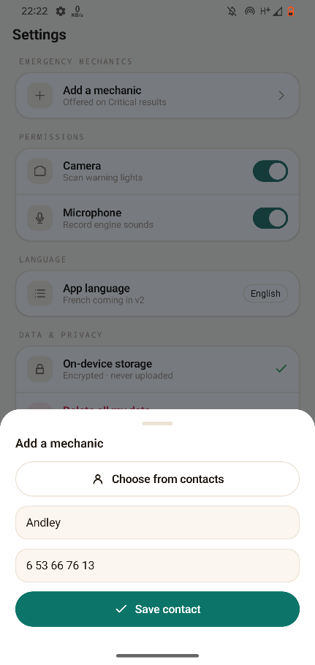  Figure 12: Settings — add a mechanic from Contacts; tap a saved mechanic to call.
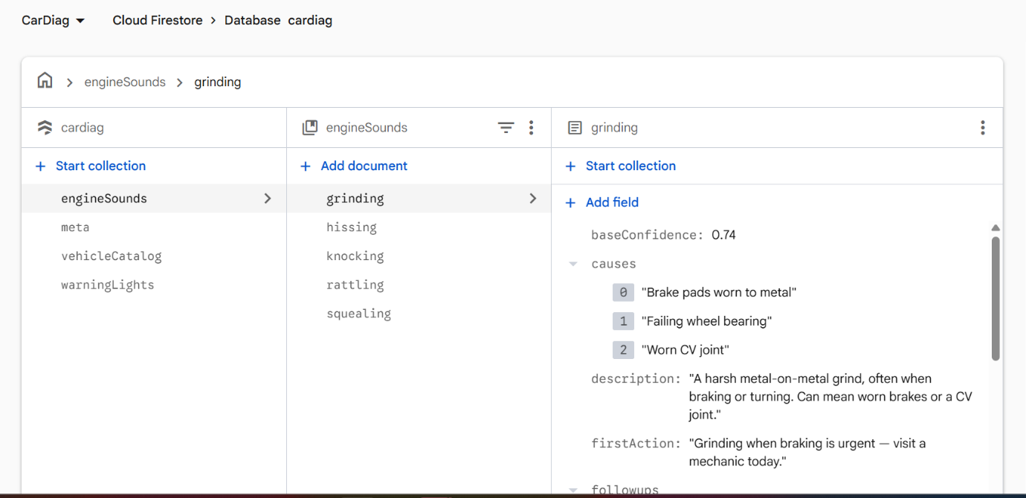
Figure 13: Firebase console — the cardiag Firestore database seeded (warningLights / engineSounds / vehicleCatalog).
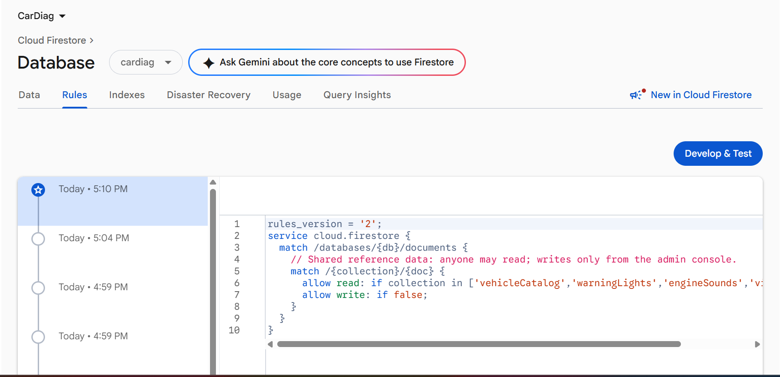
Figure 14: Firestore security rules — shared collections readable; client writes denied.

10. Requirements Traceability
Requirement | Where satisfied
DS1 knowledge base | warning_light/engine_sound (+children) in Room and on the server.
DS2 user data (private) | vehicle / diagnosis_history / emergency_contact — device-only.
FR08 Urgency | urgency lookup referenced by lights, sounds and history.
FR09 Tiered repairs | repair_suggestion + repair_tier (no_tools/basic/workshop).
FR10 Expert videos | video_link records served online.
FR11 Offline | Room seeded on first run; no network on core reads.
FR12 / UC08 Online sync | Firestore meta version + FirebaseService.syncFromFirebase() → applyDelta(); Express /delta + Retrofit as alternative.
Online store (cloud) | Firestore collections warningLights / engineSounds / vehicleCatalog / meta (catalogue version 2).
FR15 Vehicle catalogue | vehicleCatalog (Firestore + bundled) — searchable add-vehicle picker; per-vehicle photo/image.
FR15 / FR16 / FR14a | vehicle / diagnosis_history / emergency_contact tables (device-only).
NFR05 Privacy | Neither the server nor Firestore stores user data; user tables never transmitted.
NFR08 Security | Delete-all-data action; Firestore rules deny client writes; SQLCipher path for encryption at rest.
NFR09 Scalability | rev columns + db_meta/meta version enable delta updates.

11. Challenges and Design Decisions

11.1 Keeping two databases in step
Running SQLite on both the device and the server raised the risk of the two drifting apart. Seeding both from the same curated catalogue, and synchronising by revision rather than by wholesale download, keeps them consistent while minimising data transfer.

11.2 Modelling content that belongs to either a light or a sound
Repairs and videos attach to both pathways. Two nullable foreign keys with a CHECK constraint proved simpler and more referentially sound than a single generic owner column, and it lets the database reject malformed rows outright.

11.3 Honouring privacy at the schema level
Rather than treating privacy as a runtime rule, the design enforces it structurally: the server schema has no user tables at all, so private data physically cannot be stored or transmitted there.

11.4 A synchronous interface over an asynchronous store
The Task 5 repository interface is synchronous. To honour it without a rewrite, the Room database is opened for small main-thread queries at start-up while the network sync runs on a background dispatcher; a production iteration would make the repository reads suspending.

12. Conclusion
Task 6 has delivered the complete database and backend for CarDiag. The data elements were identified and documented in a data dictionary; a normalised conceptual model and an entity-relationship diagram capture the design; and the model was implemented across three stores that share one schema — an on-device Room (SQLite) database that makes the app fully offline-capable, a managed Google Cloud Firestore database that serves the shared catalogue and knowledge base online, and a self-hosted Node.js + Express + SQLite service as a portable alternative. The mobile app connects to the cloud through the Firestore SDK (and to the self-hosted server through Retrofit), performing revision-based delta synchronisation into Room — all behind the repository interface established in Task 5, so the user interface was untouched. Crucially, the design enforces the project's privacy requirement structurally by keeping all user data on the device and out of every backend.
The result is a working, verifiable data layer: the Firestore database was seeded (24 lights, 5 sounds, 40 catalogue vehicles at version 2) and read live by the app; the self-hosted server's endpoints were confirmed to return correctly assembled records; and the on-device database with both sync clients is implemented and wired into the shipped application. This database foundation supports the remaining project work and the final presentation in Task 7.

